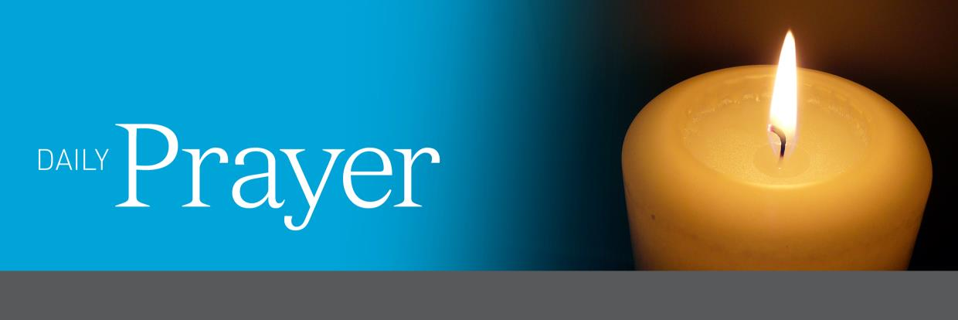

Third Sunday in Ordinary Time – Year C The Year of Luke

666666666666yh
Prayer for the Opening of the 2022 School Year The Year of Luke

Staff
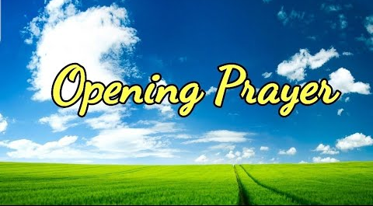
(Remind those present to take a few deep breaths to still and ready yourself for prayer)
GATHER
The Sign of the Cross
Leader: As we gather together in God’s presence, let us make the Sign of the Cross reverently and mindfully.
All: In the name of the Father, and of the Son, and of the Holy Spirit. Amen.
Opening Prayer
Leader: In gathering here today we mark the beginning of a new journey, a journey made new not only by the beginning of this New Year, but made new by the presence we bring to it.
We welcome our new staff (name new staff members) and pray that they find collegiality, friendship and warmth. As we gather here, let us be aware of all that unites us, while at the same time, honouring the diversity among us.
All: Loving God, we come together at the beginning of this year as a faith-filled community, ready and willing to celebrate all the blessings that we have been given. We pray that we may look to you as our model and guide so that we may bring the Kingdom of God to this community. We offer this prayer through Jesus Christ your Son, O Lord. Amen
LISTEN
(N.B. If possible, read from a lectionary or bible. When proclaiming the Word of God, read slowly and clearly. The text should be treated with reverence and respect.)
(Ephesians 1: 17–19)
Reader: A reading from St Paul’s letter to the Ephesians.
Brothers and sisters, I ask the glorious Father and God of our Lord Jesus Christ to give you His Spirit.
The spirit will make you wise and let you understand what it means to know God.
My prayer is that light will flood your hearts and that you will understand the hope that was given to you when God chose you. Then you will discover the glorious blessings that will be yours together with all God’s people.
(Pause)
The Word of the Lord.
RESPOND
STAFF CHARTER
All: We the staff of (insert school name) commit ourselves to this school community.

We commit to our own learning and the learning of others with an open heart and mind, prepared to be excited and amazed by new possibilities so that all may grow and be enriched.

We commit to our relationships in order to build a strong and caring staff, who listen attentively and speak kindly, who offer comfort and support in times of need, and who encourage and affirm others’ endeavours.

We commit to our school community and promise to be inclusive of all, to accept the differences and the challenges presented to us, and to understand the diverse and complex needs of our community.

We commit ourselves to our God who walks each step of the way with us, loving us and believing in us. We promise to uphold the gospel messages of compassion, justice and love, and to be a light to others and salt for the world.

We make this commitment and ask our Creator Father, Jesus His loving Son, and the life-changing Holy Spirit to be with us as we journey into 2022. Amen.

Leader: Let us offer each other a sign of peace.
GO FORTH
All: God who gathers us and unites us, we give you thanks for drawing us together in this community. May we be fired with a passion for the reign of your Kingdom, so that the dream and vision of your Son may be realised in and through our life and ministry together. This we ask in Jesus’ name. Amen.
In the name of the Father, and of the Son, and of the Holy Spirit. Amen.

Prayer for the Opening of the 2022 School Year The Year of Luke

STUDENTS
(Remind those present to turn phones to silent, close computer screens and sit quietly. Take a few deep breaths to still and ready yourself.)

GATHER
The Sign of the Cross
Leader: As we gather together in God’s presence, let us make the Sign of the Cross reverently and mindfully.
All: In the name of the Father, and of the Son, and of the Holy Spirit. Amen.
Have three candles ready to be lit.
Opening Prayer
Leader: As we begin this new year of 2022, a time of learning, discovery and of growth, let us pray
For all that we know and are yet to know… (light a candle)
All: Let us rejoice and be glad.
Leader: For all that we understand and are yet to understand… (light a candle)
All: Let us rejoice and be glad.
Leader: For all that we can do and are yet to learn… (light a candle)
All: Let us rejoice and be glad.
Leader: We make this prayer in the name of Jesus, our model and guide.
All: Amen.
Leader: God of our journey, God of hope, we your children give you thanks and praise, as we gather to begin anew our journey together. May all who are part of this community, especially all those who are new to our school, find a welcome space to grow and be. Give us the grace to begin our year, with hope and joy so that we may reach out to all those we meet. This we pray in Jesus’ name.
All: Amen
LISTEN
(N.B. If possible, read from a lectionary or bible. When proclaiming the Word of God, read slowly and clearly. The text should be treated with reverence and respect.)

Reader: A reading from St Paul’s letter to the Romans (Romans 12: 9–12)
(Pause)

Brothers and sisters:
Be sincere in your love for others.
Hate everything that is evil and hold tight to everything that is good.
Love each other as brothers and sisters and honour others more than you do yourself.
Never give up.
Eagerly follow the Holy Spirit and serve the Lord.
Let your hope make you glad. Be patient in times of trouble and never stop praying.
(Pause)

This is the Word of the Lord.

RESPOND
Leader: I invite each person to place their right hand over the shoulder of the person to their right and pray this blessing on them.
All: May the goodness of God fill your heart. May good friends share your journey. May you be valued, loved and cherished, and may God’s image grow within you. All the days of your life. Amen.
GO FORTH

Leader: Loving God, you who invite us to ask for what we need, hear now the prayers we entrust to your gracious love.

Reader: For the leaders of our community … (pause) that they be role models of justice and compassion to all members of our community.
We pray to you, O God …

All: Hear us, gracious God.

Reader: For all the new members of our community … (pause) that our new students and their families, and our new staff members find a warm and caring community here at (insert school name).
We pray to you, O God …

All: Hear us, gracious God.

Reader: For ourselves as we celebrate the beginning of another school year ... (pause) that we may have deep pockets full of the gifts of the Spirit.
We pray to you, O God …

All: Hear us, gracious God.

Reader: For the silent prayers in our hearts … (pause).
We pray to you, O God …

All: Hear us, gracious God.

Leader: May the God of community walk with us and beside us this year, sharing our journey and listening to our stories, embracing our pain, rejoicing in our triumphs. May God continue to bless our efforts to grow into a strong and vibrant community where each person accepts the invitation to celebrate all good things. And may God, the giver of life; Jesus, the eternal Word; and the Spirit who inspires us, bless us now and forever.

All: Amen.

As we begin our ‘Way of the Gospel’ journey, united as one Archdiocese:
All: Let us take the Way of the Gospel.

Extinguish candle and pause.
All: In the name of the Father, and of the Son, and of the Holy Spirit. Amen.

666666666666yh

Prayer for the Opening of the 2022 School Year The Year of Luke

Readings: Genesis 2: 18–24; Psalm 127; Hebrews 2: 9–11; Mark 10: 2–16
Today’s Daily Prayer –It is not good for the man to be alone.
Today we will pray with the First Reading. Preparation: For the response you will need a soft sounding bell, chime, or rain-stick. Choose readers and someone to light the candle.

Tuesday

Gather
Remind those present to turn phones to silent, close computer screens, sit quietly and prepare for prayer by becoming aware of God present in the Word, in each other and in ourselves. Take a few slow, deep breaths to help us attend to this moment. There may be special occasions or specific intentions that those gathered may wish to include in today’s prayer. Sound a singing bowl, a bell or a chime to begin.
The Sign of the Cross
Leader: As we gather together in God’s presence, let us make the Sign of the Cross reverently and mindfully.
All: In the name of the Father, and of the Son, and of the Holy Spirit. Amen.
Light candle and pause
Leader: We light this candle and pray that our hearts are open to God’s will in our lives.
All: Amen.
Background to the First Reading
Cultures around the world have their own origin or creation stories, ways in which they believe and describe how the Universe came to be. Many different cultures have their own creation stories that helped them understand this, including our own indigenous Australians. This story from Genesis is the second creation story and begins with God forming ‘man’ from the earth and then going on to create animals and plant life. In this reading God acknowledges that it is not good for a person to be alone for humans are social creatures who thrive on close and intimate relationships. God creates a partner, a helpmate, a companion, not someone who is beneath or lesser than but an equal and valued other. This reading reminds us that God’s intention and desire for us right from the beginning is that we find at least one other who loves us so much that we never feel alone.

Listen

Leader: Let us listen attentively to sacred scripture.
Reader: A reading from the book of Genesis
The LORD God said: "It is not good for the man to be alone.
I will make a suitable partner for him."
So the LORD God cast a deep sleep on the man,
and while he was asleep,
he took out one of his ribs and closed up its place with flesh.
The LORD God then built up into a woman the rib
that he had taken from the man.
When he brought her to the man, the man said:
"This one, at last, is bone of my bones
and flesh of my flesh;
this one shall be called 'woman,'
for out of 'her man' this one has been taken."
That is why a man leaves his father and mother
and clings to his wife,
and the two of them become one flesh.
Pause
Reader: This is the Word of the Lord.
All: Thanks be to God.

Respond
Leader: Let us pray that all we do and say comes from love.
All: Loving God,
Give me the courage to build my life on a foundation of love.
(Sound gentle chimes or rain-stick or soft bell and pause for a moment.)
Give me the courage to speak only words of love.
(Sound gentle chimes or rain-stick or soft bell and pause for a moment.)
Give me the courage to love those who feel most unloved and alone.
(Sound gentle chimes or rain-stick or soft bell and pause for a moment.)
Give me the courage to love others respectfully, justly and tenderly.
(Sound gentle chimes or rain-stick or soft bell and pause for a moment.)
Give me the courage to walk gently and kindly with others.
(Sound gentle chimes or rain-stick or soft bell and pause for a moment.)
Amen.
Pause

Go Forth
Leader: May we go forth with hearts full of love and joy.
All: Amen.
Leader: May we go forth with hearts full of tenderness and compassion.
All: Amen.
Leader: May we go forth with hearts full of kindness and peace.
All: Amen.
Extinguish candle and pause.
As we begin our ‘Way of the Gospel’ journey, united as one Archdiocese:
All: Let us take the Way of the Gospel.

Extinguish candle and pause.
All: In the name of the Father, and of the Son, and of the Holy Spirit. Amen.

666666666666yh

Prayer for the Opening of the 2022 School Year The Year of Luke

Readings: Genesis 2: 18–24; Psalm 127; Hebrews 2: 9–11; Mark 10: 2–16
Today’s Daily Prayer – May the Lord bless us all the days of our lives.
Today we will focus on the Responsorial Psalm. Preparation: Choose readers for the various parts and someone to light the candle.

Wednesday

Gather
Remind those present to turn phones to silent, close computer screens, sit quietly and prepare for prayer by becoming aware of God present in the Word, in each other and in ourselves. Take a few slow, deep breaths to help us attend to this moment. There may be special occasions or specific intentions that those gathered may wish to include in today’s prayer. Sound a singing bowl, a bell or a chime to begin.
The Sign of the Cross
Leader: As we gather together in God’s presence, let us make the Sign of the Cross reverently and mindfully.
All: In the name of the Father, and of the Son, and of the Holy Spirit. Amen.
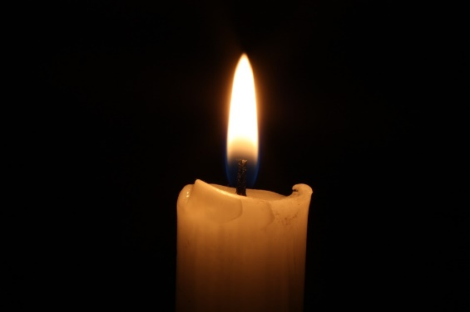
Light candle and pause.
Candlelight, Pixabay (CC0 Public Domain)
Leader: As we light this candle…
All: May we be blessed with loving hearts.
Leader: As we light this candle…
All: May we be blessed with peaceful hearts.
Leader: As we light this candle…
All: May we be blessed with grateful hearts.
Background to the Responsorial Psalm
Psalm 128 is a psalm of blessing on a faithful and loving family man, the ideal man. He would have come to the Temple to give sacrifice and receive this blessing. This man who fears the Lord (who is in awe of God) will be blessed with a fertile wife, have many children, will be rich and will live a long life, long enough to see his grandchildren (something we take for granted these days). There are two agricultural references here – the wife is described as a fertile vine bearing many children; and the children as olive plants which would bring the man great wealth – both of which the Jewish people would understand as symbols of a man whom God has blessed.

Listen
If possible, the scripture passage is to be read from a lectionary or a bible, which could be put in an honoured place. Readers are to read slowly and clearly when proclaiming the word of God and treat the text with reverence.
Leader: Let us pray together the Responsorial Psalm.
Reader: May the Lord bless us all the days of our lives.
All: May the Lord bless us all the days of our lives.
Reader: Blessed are you who fear the LORD,
who walk in his ways!
For you shall eat the fruit of your handiwork;
blessed shall you be and favoured.
All: May the Lord bless us all the days of our lives.
Reader: Your wife shall be like a fruitful vine
in the recesses of your home;
your children like olive plants
around your table.
All: May the Lord bless us all the days of our lives.
Reader: Behold, thus is the man blessed
who fears the LORD.
The LORD bless you from Zion:
may you see the prosperity of Jerusalem
all the days of your life.
All: May the Lord bless us all the days of our lives.
Reader: May you see your children's children.
Peace be upon Israel!
All: May the Lord bless us all the days of our lives.
Pause

Respond
Leader: Let us take some quiet time to reflect on the response:
May the Lord bless us all the days of our lives.
How has God blessed you in your life?
How do you want God to bless you in the future?
Time for quiet reflection.

Go Forth
All: Loving God,
You call us to be compassionate,
You call us to be merciful,
You call us to grateful.
You call us to be people of justice,
You call us to be witnesses of your Word,
You call us to the way of peace and love.
May it be so.
Amen.
Extinguish candle and pause.
As we begin our ‘Way of the Gospel’ journey, united as one Archdiocese:
All: Let us take the Way of the Gospel.

Extinguish candle and pause.
All: In the name of the Father, and of the Son, and of the Holy Spirit. Amen.

666666666666yh

Prayer for the Opening of the 2022 School Year The Year of Luke

Readings: Genesis 2: 18–24; Psalm 127; Hebrews 2: 9–11; Mark 10: 2–16
Today’s Daily Prayer – He is not ashamed to call them brothers.
Today’s prayer will focus on the Second Reading. Preparation: Choose readers and a person to light the candle.

Thursday

Gather
Remind those present to turn phones to silent, close computer screens, sit quietly and prepare for prayer by becoming aware of God present in the Word, in each other and in ourselves. Take a few slow, deep breaths to help us attend to this moment. There may be special occasions or specific intentions that those gathered may wish to include in today’s prayer. Sound a singing bowl, a bell or a chime to begin.
The Sign of the Cross
Leader: As we gather together in God’s presence, let us make the Sign of the Cross reverently and mindfully.
All: In the name of the Father, and of the Son, and of the Holy Spirit. Amen.
Light candle and pause.
Leader: As we light this candle, we do so with humble hearts knowing that God‘s love for us is deep and everlasting. (Pause)
Background to the Second Reading
The letter to the Hebrews was not written to a particular community addressing particular issues as in letters such as Ephesians or Corinthians. It was a letter which addressed a bigger idea - Jesus as the key to salvation. After the destruction of the Temple, Jewish people lost a sense of identity which they had found in the Temple. The author here suggests that Jesus was the new focus, the new centre of life. He came from God, but lived like one of us, suffered and died, conquered death and helped us see how we could have a relationship with God. Through Jesus, we can see that God is active and walks among us.

Listen
Leader: Let us listen attentively to sacred scripture.
Reader: A reading from the letter to the Hebrews.
We see in Jesus one who was for a short while made lower than the angels and is now crowned with glory and splendour because he submitted to death; by God’s grace he had to experience death for all mankind.
That is why he openly calls them brothers and sisters. (Pause)
Reader: This is the word of the Lord.
All: Thanks be to God.

Respond
Prayer of the Faithful
Leader: Let us bring our prayers before God who is loving and merciful.
Reader: That we may be Jesus’ brothers and sisters by showing love and compassion to all. (pause) Lord, hear us.
All: Lord, give us a heart of love.
Reader: That we may be Jesus’ brothers and sisters by working for justice and equality. (pause) Lord, hear us.
All: Lord, give us a heart of love.
Reader: That we may be Jesus’ brothers and sisters by being tolerant and understanding. (pause) Lord, hear us.
All: Lord, give us a heart of love.
Reader: That we may be Jesus’ brothers and sisters by raising up the lowly and the poor. (pause) Lord, hear us.
Heart, Pixabay (CCO Public Domain)
All: Lord, give us a heart of love.
Reader: That we may be Jesus’ brothers and sisters by focusing fully on seeking the will of God and living it. (pause) Lord, hear us.
All: Lord, give us a heart of love.
Reader: For our own intentions….. (pause) Lord, hear us.
All: Lord, give us a heart of love.
Leader: Hear our prayers Lord, and grant that we may always know the love of Christ in our lives.
All: Amen

Go Forth
Leader: Loving God, you pour your abundant blessings upon us and shower us with all good things. Help us to remember that you love us because of who you are not for what we do or say. Give us hearts filled with humility so that we can see beyond ourselves and be open to the needs of others. We ask this prayer in Jesus’ name.
All: Amen

Extinguish candle and pause
As we begin our ‘Way of the Gospel’ journey, united as one Archdiocese:
All: Let us take the Way of the Gospel.

Extinguish candle and pause.
All: In the name of the Father, and of the Son, and of the Holy Spirit. Amen.

666666666666yh

Prayer for the Opening of the 2022 School Year The Year of Luke

Readings: Genesis 2: 18–24; Psalm 127; Hebrews 2: 9–11; Mark 10: 2–16
Today’s Daily Prayer – The world of your action and activity is a precious world.
Today’s prayer is taken from Anam Cara by John O’Donohue. Preparation: Each person present will need some paper and a pen/pencil. Choose readers and someone to light the candle.

Friday

Gather
Remind those present to turn phones to silent, close computer screens, sit quietly and prepare for prayer by becoming aware of God present in the Word, in each other and in ourselves. Take a few slow, deep breaths to help us attend to this moment. There may be special occasions or specific intentions that those gathered may wish to include in today’s prayer. Sound a singing bowl, a bell or a chime to begin.
The Sign of the Cross
Leader: As we gather together in God’s presence, let us make the Sign of the Cross reverently and mindfully.
All: In the name of the Father, and of the Son, and of the Holy Spirit. Amen.
Light candle and pause.
Leader: As we gather together to pray, we do so with humble hearts knowing that God’s love for us is deep and everlasting.
All: Amen

Listen

Spiritual Reading from Anam Cara by John O’Donohue (p. 188)

Leader: Today’s reflection comes from John O’Donohue’s book Anam Cara. Whether you are a student, teacher or have some other role, you all have a job to do. Let us listen to this passage keeping our role and the work we do in mind.
Reader: When you consider it, the world of your action and activity is a very precious world. What you do should be worthy of your attention and dignity and conform to your respect for yourself. If you can love what you do, then you will do it beautifully. You might not love your work at the beginning, yet the deeper side of your soul can help you bring the light of love to what you do. Then regardless of what you do, you will do it in a creative and transforming way.

Respond
Leader: Take some time to slowly reread this excerpt. What words speak to you most loudly and clearly?
Write those words down on your page. What do they mean for you?
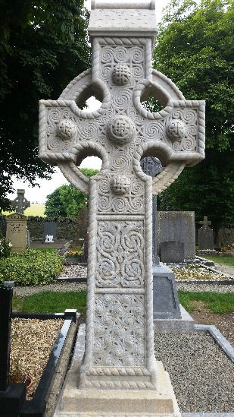
Share your thoughts with another person near you.

Image: M. Cosgriff

Time for quiet reflection.

Go Forth
Blessing from Anam Cara by John O’Donohue (p. 200)

Leader: May the light of your soul guide you.

May the light of your soul bless the work you do

with the secret love and warmth of your heart.

May you see in what you do the beauty of your own soul.

May the sacredness of your work bring healing, light and renewal

to those who work with you and to those who see and receive your work. May your soul calm, console and renew you.

All: Amen.

Image: M. Cosgriff
The Sign of Peace
Leader: As we come to the end of another week, let us offer each other a sign of peace.
(Sign of peace.)

Extinguish candle and pause.
All: In the name of the Father, and of the Son, and of the Holy Spirit. Amen.

As we begin our ‘Way of the Gospel’ journey, united as one Archdiocese:
All: Let us take the Way of the Gospel.

Extinguish candle and pause.
All: In the name of the Father, and of the Son, and of the Holy Spirit. Amen.

References

O’Donohue, J. Anam Cara: Spiritual Wisdom from the Celtic World. NSW: Transworld Publishers, 1997. p. 198-200.

