666666666666yh

Twenty-eighth Sunday in Ordinary Time – B The Year of Mark

Readings: Wisdom 7: 7–11; Psalm 89: 12–17; Hebrews 4: 12–13; Mark 10: 17–30

Using Daily Prayer
The following daily prayers can be used in their entirety or adapted to meet the needs of the audience, or you may choose to use the shorter version indicated by the green headings. The prayers draw on the Sunday readings, so you may use any of the prayers on any day, although special focus will be given to Feast days, Solemnities and days of special cultural significance.
Daily Prayer focuses on the readings from the previous Sunday’s liturgy. It aims to give students and staff an opportunity to reflect on the Word of God and see its relevance to their own lives. It also seeks to give them some understanding of cultural, historical and social aspects of the readings.
The prayers introduce students to traditional prayer and liturgical practices and responses, as well as a variety of Christian spiritual experiences. Take the opportunity to create a Sacred Space for prayer as you might do in creating a protected garden. This may include a prayer cloth or place mat, a Bible, a candle and flowers.

Readings this week
This week’s readings are about the importance of seeking wisdom – wisdom to know that the way to eternal life is not measured by how much we have, nor by our wealth or social status. It is measured by how we stand with the poor and share in their hardships. It is measured – in the words of St Teresa of Avila – by the way we are the face of Christ to others, the way we are his hands and feet in the world and the way we listen and attend to the cries of the poor and oppressed.

Overview of the Week
Day and Liturgical Colour | Daily Prayer | Links to Liturgy, Traditional Prayers &  Forms of Prayer
Monday – Green | I pleaded, and the spirit of wisdom came to me. | Praying with the First Reading. Collect. Meditation. Blessing.
Tuesday – Green | Fill us with your love, O Lord, and we will sing for joy. | Praying with the Responsorial Psalm. Responding in song.
Wednesday – Green | The word of God is living and effective. | Praying with the Second Reading. Reflecting on Psalm 139. Sign of the Cross.
Thursday –Green | What must I do to inherit eternal life. | Praying with the Gospel. Standing for the Gospel. Gospel acclamation. Augustinian lectio.
Friday – Green  Feast of St Teresa of Avila | Christ has no body now but yours | Praying with the words of St Teresa. Reflection time. Prayer of the Faithful. Sign of peace.
Note that scripture quotations are from the Lectionary or NRSV.

Suggested Teacher Background for the Readings
- LiturgyHelp: Commentaries and Homilies & Reflections
- Loyola Press: Sunday Connection
- The Emmaus Series: Sunday Reflections

666666666666yh

Twenty-eighth Sunday in Ordinary Time – B The Year of Mark

Readings: Wisdom 7: 7–11; Psalm 89: 12–17; Hebrews 4: 12–13; Mark 10: 17–30
Today’s Daily Prayer – I pleaded, and the spirit of wisdom came to me.
Today’s prayer focuses on the First Reading. Preparation: Choose readers and someone to light the candle.

Monday

Gather
Remind those present to turn phones to silent, close computer screens, sit quietly and prepare for prayer by becoming aware of God present in the Word, in each other and in ourselves. Take a few slow, deep breaths to help us attend to this moment. There may be special occasions or specific intentions that those gathered may wish to include in today’s prayer. Sound a singing bowl, a bell or a chime to begin.
The Sign of the Cross
Leader: As we gather together in God’s presence, let us make the Sign of the Cross reverently and mindfully.
All: In the name of the Father, and of the Son, and of the Holy Spirit. Amen.
Light candle and pause.
Leader: As we gather together to pray, we do so with humble hearts knowing that God’s love for us is deep and everlasting.
All: Amen
Background to the First Reading
The First Reading comes from the Wisdom of Solomon, a collection of proverbs and wise sayings attributed to King Solomon, son of King David. It was written after the return of the Jewish people from captivity in Babylon. Jews were living in many parts of the known world and, in many places were often torn between their religious beliefs and Greek culture. The writer wanted to say that there was also much merit in Jewish wisdom. He tells his audience that God’s Wisdom is rare and precious and it is to be sought after more than anything else.

Listen
Leader: Let us listen attentively to sacred scripture.
Reader: I prayed, and prudence was given me;
I pleaded, and the spirit of wisdom came to me.
I preferred her to sceptre and throne,
and deemed riches nothing in comparison with her,
nor did I liken any priceless gem to her;
because all gold, in view of her, is a little sand,
and before her, silver is to be accounted mire.
Beyond health and comeliness I loved her,
and I chose to have her rather than the light
because the splendour of her never yields to sleep.
Yet all good things together came to me in her company,
and countless riches at her hands.
Wisdom, Pixabay (CC0 Public Domain)
Pause
Reader: The Word of the Lord.
All: Thanks be to God.

Respond
Leader: Sit quietly on your chair with feet on the floor and your hands in your lap.
Close your eyes and slow your breathing into a gentle rhythm.
Breathe in slowly. Breathe out slowly. (3-4 times)
Before money and wealth, O Lord, give me wisdom. (pause) Give me wisdom. (pause)
Before precious gems, gold and silver, O Lord, give me wisdom. (pause) Give me wisdom. (pause)
Before power and position, O Lord, give me wisdom. (pause) Give me wisdom. (pause)
Before belongings and possessions, O Lord, give me wisdom. (pause) Give me wisdom. (pause)
Before words of praise and approval, O Lord, give me wisdom. (pause) Give me wisdom. (pause)
Before fine looks and outward beauty, O Lord, give me wisdom. (Pause) Give me wisdom. (pause)
O Lord, I pray, above all else give me wisdom
Count back slowly from 5-1 and open your eyes.
Time for quiet reflection.

Go Forth
Leader: Wisdom shines bright and never grows dim: those who love her and look for her can easily find her.
All: Loving God, fill us with the spirit of wisdom.
Leader: If you look for her, you will soon find peace of mind;
she is kind and will be with you in your every thought
All: Loving God, fill us with the spirit of wisdom. Amen

Extinguish candles and pause
All: In the name of the Father, and of the Son, and of the Holy Spirit. Amen

666666666666yh

Twenty-eighth Sunday in Ordinary Time – B The Year of Mark

Readings: Wisdom 7: 7–11; Psalm 89: 12–17; Hebrews 4: 12–13; Mark 10: 17–30
Today’s Daily Prayer – Fill us with your love, O Lord, and we will sing for joy.
Today we will pray with the Responsorial Psalm. Preparation: Choose readers and someone to light the candle.

Tuesday

Gather
Remind those present to turn phones to silent, close computer screens, sit quietly and prepare for prayer by becoming aware of God present in the Word, in each other and in ourselves. Take a few slow, deep breaths to help us attend to this moment. There may be special occasions or specific intentions that those gathered may wish to include in today’s prayer. Sound a singing bowl, a bell or a chime to begin.
The Sign of the Cross
Leader: As we gather together in God’s presence, let us make the Sign of the Cross reverently and mindfully.
All: In the name of the Father, and of the Son, and of the Holy Spirit. Amen.
Light candle and pause
Leader: We light this candle and pray that our hearts are open to God’s love in our lives. May we rejoice, delighting in the knowledge that God loves us and cares for us today and always.
All: Amen.
Background to the Responsorial Psalm
The author of Psalm 90 appealed to God for help but seemed unsure as to whether this would happen. In the end though, his faith prevailed, and he trusted God anew. He began by referring to God’s presence and power and compared it to human’s frailty. Humans’ existence seemed to be so transient and the psalmist becomes overwhelmed with the burden of life. He calls to God to show mercy and help him see that the sufferings he has endured will help him to remain faithful. The psalmist calls on God to stay with his community and to bless the present and future generations just as God did in the past.

Listen
Reader: Fill us with your love, O Lord, and we will sing for joy!
All: Fill us with your love, O Lord, and we will sing for joy!
Reader: Teach us to number our days aright,
that we may gain wisdom of heart.
Return, O LORD! How long?
Have pity on your servants!
All: Fill us with your love, O Lord, and we will sing for joy!
Reader: Fill us at daybreak with your kindness,
that we may shout for joy and gladness all our days.
Make us glad, for the days when you afflicted us,
for the years when we saw evil.
All: Fill us with your love, O Lord, and we will sing for joy!
Reader: Let your work be seen by your servants
and your glory by their children;
and may the gracious care of the LORD our God be ours;
prosper the work of our hands for us!
Prosper the work of our hands!
All: Fill us with your love, O Lord, and we will sing for joy!
Pause

Respond
Leader: Let us respond to the psalm in song:
Fill Us with Your Love, O Lord by Carol Browning
Fill Us with Your Love by Craig Colson
Pixabay, (CC0 Public Domain)
Pause

Go Forth
Leader: Let us go with hearts full of joy.
All: Amen.
Leader: Let us go with hearts full of hope.
All: Amen.
Leader: Let us go with hearts full of faith.
All: Amen.
Extinguish candle and pause.
All: In the name of the Father, and of the Son, and of the Holy Spirit. Amen.

666666666666yh

Twenty-eighth Sunday in Ordinary Time – B The Year of Mark

Readings: Wisdom 7: 7–11; Psalm 89: 12–17; Hebrews 4: 12–13; Mark 10: 17–30
Today’s Daily Prayer – The word of God is living and effective.
Today we will focus on the Second Reading. Preparation: Choose readers for the various parts and someone to light three candles.

Wednesday

Gather
Remind those present to turn phones to silent, close computer screens, sit quietly and prepare for prayer by becoming aware of God present in the Word, in each other and in ourselves. Take a few slow, deep breaths to help us attend to this moment. There may be special occasions or specific intentions that those gathered may wish to include in today’s prayer. Sound a singing bowl, a bell or a chime to begin.
The Sign of the Cross
Leader: As we gather together in God’s presence, let us make the Sign of the Cross reverently and mindfully.
All: In the name of the Father, and of the Son, and of the Holy Spirit. Amen.
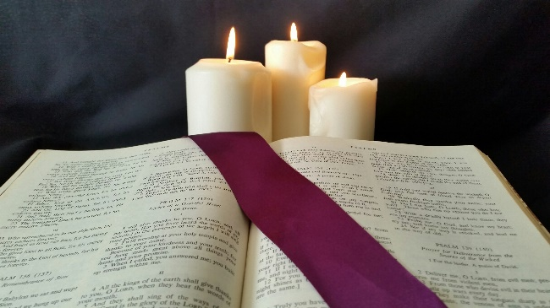
Light candles and pause.
Leader: As we light this candle…
All: May our thoughts be generous and uplifting.
Leader: As we light this candle…
All: May our words be kind and gentle.
Leader: As we light this candle…
All: May our hearts be filled with love and peace. Amen.
Background to the Second Reading
Image: Moira Cosgriff. Used with permission
At the time the letter to the Hebrews was written, social status was all important. People were judged by their home, family, wealth, what they said and did. So, if you wanted to conceal something that might reduce your social standing you would need to be very careful. In this reading, the writer says that God can cut through all our pretensions and deceit like a sharp-edged sword. He can open up our hearts to reveal what is there, not to judge and condemn, but to bring healing and grace.

Listen
If possible, the scripture passage is to be read from a lectionary or a bible, which could be put in an honoured place. Readers are to read slowly and clearly when proclaiming the word of God and treat the text with reverence.
Leader: Let us listen attentively to the words of sacred scripture.
Reader: Brothers and sisters:
Indeed the word of God is living and effective,
sharper than any two-edged sword,
penetrating even between soul and spirit, joints and marrow,
and able to discern reflections and thoughts of the heart.
No creature is concealed from him
but everything is naked and exposed to the eyes of him
to whom we must render an account.
Pause
Reader: This is the Word of the Lord.
Image: V. Forsayeth, Used with permission
All: Thanks be to God.

Respond
Leader: Let us pray some of the verses from Psalm 139 which reflect the thoughts of this reading.
Reader: Lord, you have examined me, and you know me.
You know everything I do;
from far away you understand all my thoughts;
You see me whether I am working or resting
you know all my thoughts. (Pause and reflect)
Reader: If I flew away beyond the east
or lived in the farthest place in the west,
you would be there to lead me,
you would be there to help me. (Pause and reflect)
Reader: Examine me O God, and know my mind;
test me and discover my thoughts.
Find out if there is any evil in me,
and guide me in your everlasting ways.
Time for quiet reflection.

Go Forth
Leader: Let us pray this prayer together.
All: May God be in my mind that I may think of you. (Make sign of the cross on your forehead with your thumb.)
May God be on my lips that I may speak of you. (Make sign of the cross on your lips with your thumb.)
May God be in my heart that I may love you. (Make sign of the cross on your heart with your thumb.)
All: Amen.

Extinguish candle and pause.
All: In the name of the Father, and of the Son, and of the Holy Spirit. Amen.

666666666666yh

Twenty-eighth Sunday in Ordinary Time – B The Year of Mark

Readings: Wisdom 7: 7–11; Psalm 89: 12–17; Hebrews 4: 12–13; Mark 10: 17–30
Today’s Daily Prayer – What must I do to inherit eternal life?
Today’s prayer will focus on the Gospel. Preparation: Choose readers and a person to light the candle.

Thursday

Gather
Remind those present to turn phones to silent, close computer screens, sit quietly and prepare for prayer by becoming aware of God present in the Word, in each other and in ourselves. Take a few slow, deep breaths to help us attend to this moment. There may be special occasions or specific intentions that those gathered may wish to include in today’s prayer. Sound a singing bowl, a bell or a chime to begin.
The Sign of the Cross
Leader: As we gather together in God’s presence, let us make the Sign of the Cross reverently and mindfully.
All: In the name of the Father, and of the Son, and of the Holy Spirit. Amen.
Light candle and pause.
Leader: As we light this candle, let us pray together the Opening Prayer from last Sunday’s liturgy.
All: May your grace, O Lord, we pray,
at all times go before us and follow after us
and make us always determined
to carry out good works.
Background to the Gospel
In biblical times a rich man was measured by his possessions – a substantial house, fine clothes, good food, plenty of herds of animals, an obedient wife and lots of children. This man was highly favoured by God. He was blessed indeed. Imagine the shock of the crowd gathered around Jesus as he tells the rich young man to give away his possessions - to give them away to the poor! The poor are the least blessed, the least favoured by God. Jesus implies that to be a part of the Kingdom it is necessary to share in the hardships of others and support them in their time of need.

Listen
Leader: Let us stand to greet the gospel.
All: Alleluia, alleluia.
Happy the poor in spirit:
the Kingdom of heaven is theirs!
Alleluia, alleluia.
Reader: The Lord be with you
All: And with your spirit.

Reader: A reading from the holy Gospel according to Mark.

All: Glory to you, O Lord.

Mindfully trace the Sign of the Cross on the forehead, the lips and the heart.
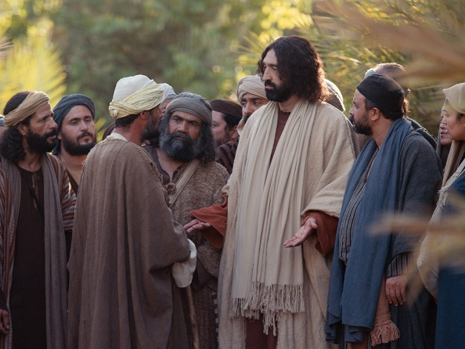
Reader: As Jesus was setting out on a journey, a man ran up,
knelt down before him, and asked him,
"Good teacher, what must I do to inherit eternal life?"
Jesus answered him, "Why do you call me good?
No one is good but God alone.
You know the commandments: You shall not kill;
you shall not commit adultery;
you shall not steal;
you shall not bear false witness;
you shall not defraud;
honor your father and your mother."
He replied and said to him,
"Teacher, all of these I have observed from my youth."
Jesus, looking at him, loved him and said to him,
"You are lacking in one thing. Go, sell what you have, and give to the poor
and you will have treasure in heaven; then come, follow me."
At that statement his face fell, and he went away sad, for he had many possessions.
The rich man, www.LumoeProject.com

(Pause)
Reader: This is the gospel of the Lord.
All: Praise to you Lord Jesus Christ.

Respond
Augustinian Lectio
Leader: I invite you to re-read the Gospel and imagine that you are that young man and Jesus is speaking to you.
Take some time to think and reflect on your reaction.
Time for quiet reflection
Share your thoughts with two or three others near you.

Go Forth
Leader: Loving God, you call us to be your faithful followers and invite us to be part of the Kingdom of God. Give us strength when we waver, support us when we fall, call us back to you when we turn away from you. May we be your true disciples willing to give up everything to walk your ways. We ask this prayer in Jesus’ name.
All: Amen
Extinguish candle and pause
All: In the name of the Father, and of the Son, and of the Holy Spirit. Amen
666666666666yh

Twenty-eighth Sunday in Ordinary Time – B The Year of Mark

Readings: Wisdom 7: 7–11; Psalm 89: 12–17; Hebrews 4: 12–13; Mark 10: 17–30

Today’s Daily Prayer – Christ has no body now but yours

Today’s prayer focuses on the feast of St Teresa of Avila. Preparation: Choose readers and someone to light the candle.

Friday

Gather
Remind those present to turn phones to silent, close computer screens, sit quietly and prepare for prayer by becoming aware of God present in the Word, in each other and in ourselves. Take a few slow, deep breaths to help us attend to this moment. There may be special occasions or specific intentions that those gathered may wish to include in today’s prayer. Sound a singing bowl, a bell or a chime to begin.
The Sign of the Cross
Leader: As we gather together in God’s presence, let us make the Sign of the Cross reverently and mindfully.
All: In the name of the Father, and of the Son, and of the Holy Spirit. Amen.
Leader: Today is the feast day of St. Teresa of Avila. As we light this candle, let us pray together these words of St Teresa.

All: Reflect upon the providence and wisdom of God in all created things and praise God in them all. (Pause)

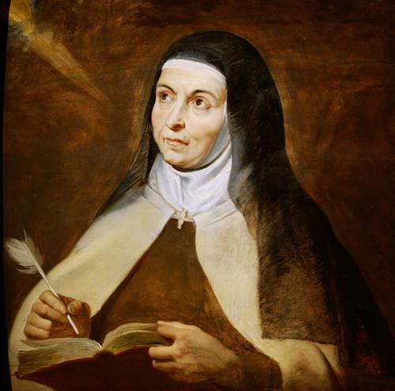
Listen
St Teresa of Avila, by Peter Paul Reubens, 1615
Leader: Let us listen to some words of St. Teresa.
Reader: Christ has no body now, but yours. No hands, no feet on earth, but yours. Yours are the eyes through which Christ looks compassion into the world. Yours are the feet with which Christ walks to do good. Yours are the hands with which Christ blesses the world. (Pause)
Reader: Let nothing disturb you,
Let nothing frighten you,
All things are passing away:
God never changes.
Patience obtains all things
Whoever has God lacks nothing;
God alone suffices. (Pause)
Reader: We need no wings to go in search of God but have only to look upon God present within us. (Pause)

Respond

Prayer of the Faithful
Leader: Gracious and ever-present God, we bring our prayers before you knowing that you are always listening to us.
Reader: That we may have the courage to be Christ’s hands and reach out to others in need … (pause) Lord, hear us.
All: Lord, hear our prayer.
Reader: That we may have compassionate hearts and be willing to walk in another’s shoes so as to increase our understanding … (pause) Lord, hear us.
All: Lord, hear our prayer.
Reader: That we may become nurturing disciples using our eyes and ears to see the needs of others and to hear their cries … (pause) Lord, hear us.
All: Lord, hear our prayer.
Reader: That we may be the face of Christ to others and see the face of Christ in each person we meet … (pause) Lord, hear us.
All: Lord, hear our prayer.
Reader: For our own intentions…(pause) Lord, hear us.
All: Lord, hear our prayer.
Leader: Loving God, with hope and faith we ask you to accept the prayers we make to you.
All: Amen.

Go Forth
Blessing of Teresa of Avila
Leader: May today there be peace within.
May you trust God that you are exactly where you are meant to be.
May you not forget the infinite possibilities that are born of faith.
May you use those gifts that you have received and pass on love that has been given to you.
May you be content knowing you are a child of God. Let this presence settle into your bones, and allow your soul the freedom to sing, dance, praise and love. It is there for each and every one of us.
Extinguish candles and pause
All: In the name of the Father, and of the Son, and of the Holy Spirit. Amen.

