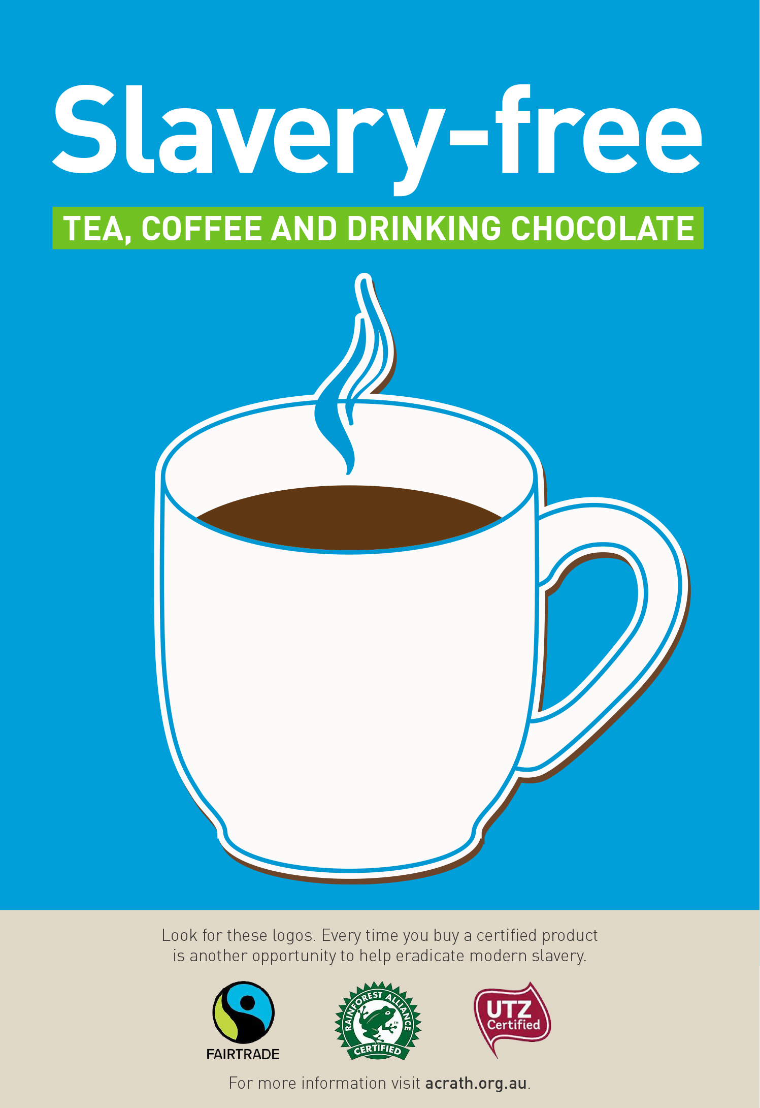

In the coming months you will notice a gradual change to **slavery-free** tea, coffee and drinking chocolate products in your staffroom.

Knowing that they have been produced and supplied ethically and sustainably should give you an extra pep in your step!

– <insert organisation name> NOW SERVING –